Question 11:
Create a dictionary that stores five English words and their meanings. Access each meaning.
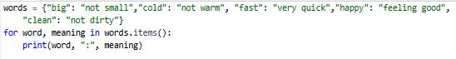
Output:
